Star City Canine Training Club of Roanoke, VA presents:*

Canine Conditioning Workshop - Obedience Performance

By

PETRA FORD, PT, CCRT of

AQUA DOG REHABILITATION, LLC

www.aquadogrehab.com

Does your dog sit crooked on fronts and finishes? Have a sloppy sit, sit on one hip or lie down on the sit stay? Have difficulty trotting, bending on the inside of the figure eight? Bump you on a left turn? Have a slow drop, or have forward motion with the drop? Tick or knock the jump or jump with poor style? Did you ever consider that these problems might be PHYSICAL? Learn how to improve your dog’s performance by strengthening, conditioning and improving his physical skills!
This course will cover:
Super Sits: tight, straight and strong sits are required for stays, halts, fronts and finishes
Fabulous Fronts: hind end awareness exercises for reliable, accurate fronts
Fantastic Finishes: more hind end awareness for consistently straight finishes
Super Stands: strengthening exercises for a solid stand for exam and signal stand
Dazzling Drops: exercises targeting muscles needed for quick drops (recalls and signals) with no creeping
Jazzy Jumping: hind end strengthening to promote good jumping style that easily clears jumps

Day 2, April 23, Sunday, 2017 ~~ 9am – 4pm

*WORKING SPOT: $150 ($275 for both workshops, see attached flyer)

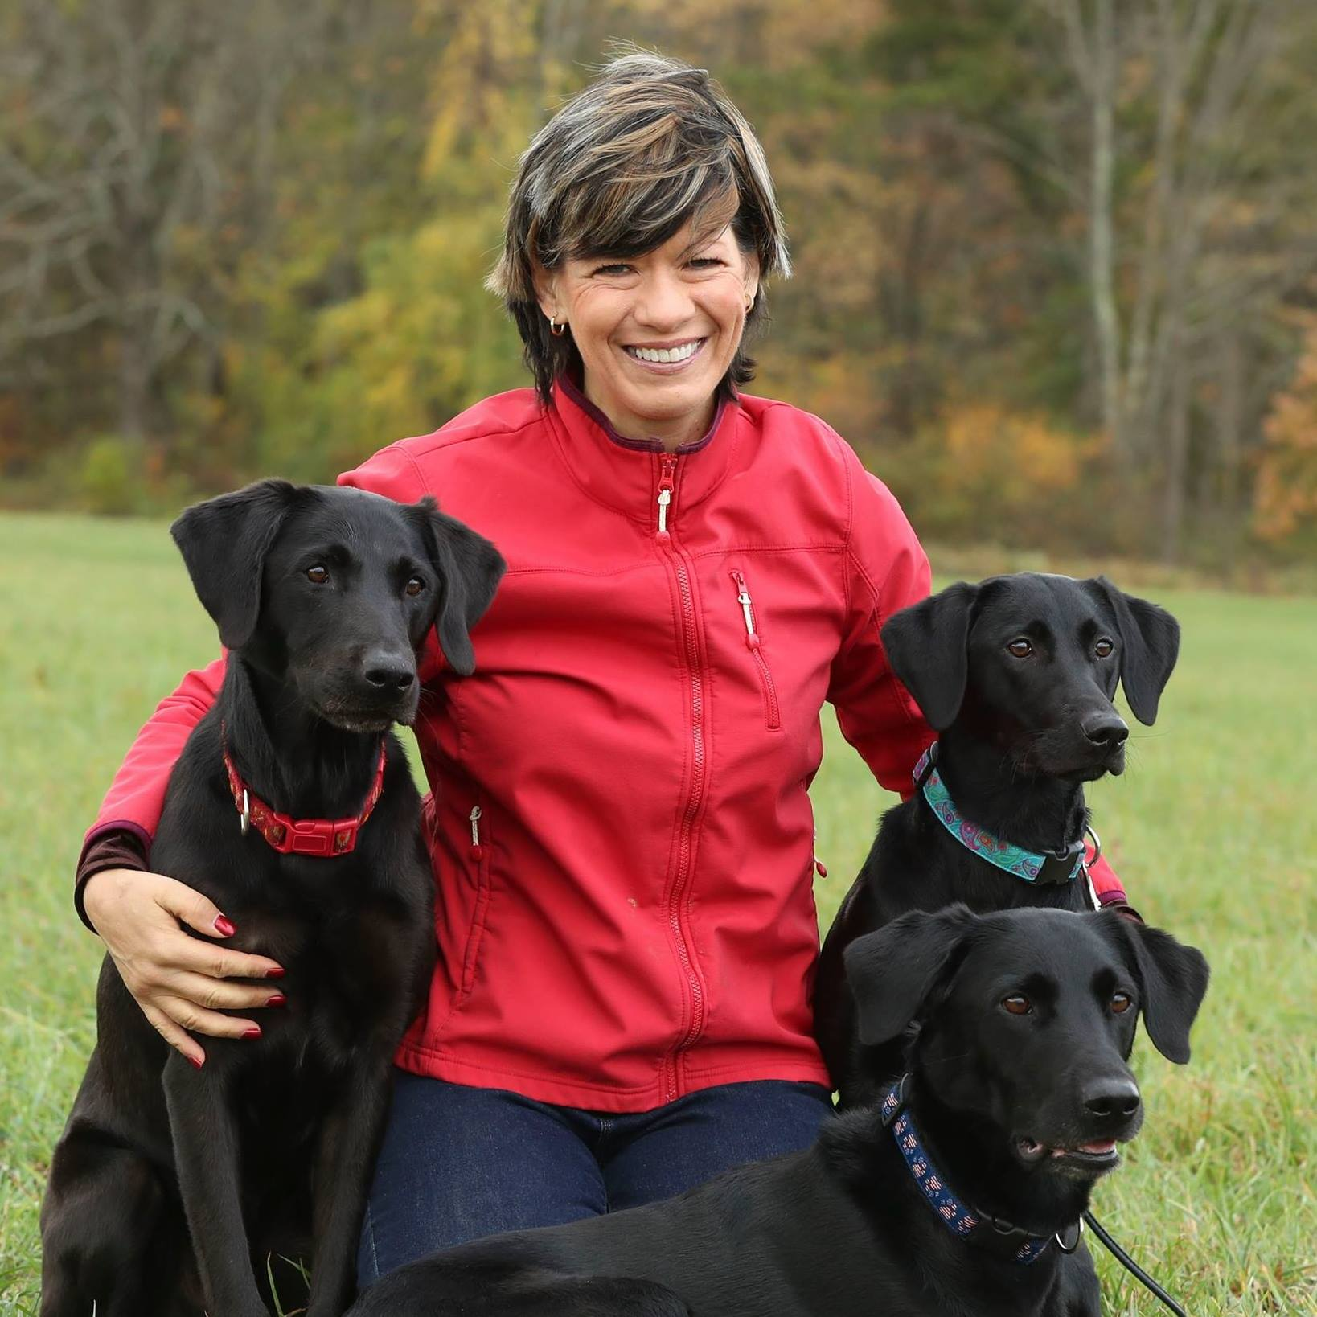
AUDITING SPOT: $100

Star City Canine Training Club of Roanoke, VA presents:

CANINE CONDITIONING
Maximizing Performance and Preventing Injuries
Day 1, Saturday, April 22, 2017

Petra Ford, PT, CCRT of

Aqua Dog Rehabilitation, LLC

www.aquadogrehab.com

Do you want to improve your course time? Improve your Q rate? Minimize knocked bars? Improve speed and control over contact equipment?
Whether you compete in agility, obedience, schutzhund, herding, field work, etc. This seminar will provide you with the tools to develop a personalized conditioning program for your dog that will improve your athlete’s performance!

At this hands-on seminar we will teach:
*Structure for function to identify potential areas of weakness

*Importance of a proper warm-up and cool down
*Stretching for injury prevention and early identification of injuries

*Components of a conditioning program
*How to develop a personalized conditioning program that will target your dog’s needs
*

WORKING SPOT: $150 ($275 for both workshops, see adjoining flyer for Sunday)

Auditing spot: $100

Contact: Mitzi Tinaglia, 540 353 5013, mitzi591@gmail.com

*Checks payable to: SCCTC, Mail to: Mitzi Tinaglia 6869 Merriman RD, Roanoke, VA 24018

